**Arduino Project**

**Autonomous electric car**

**Tudorica Andrei**, group 30411

E-mail: andreitudoricacj@gmail.com

The "Autonomous electric car" Project is a self driving car, built by the A3 team, for the Electro Mobility contest. The car is able to work in two modes: Autonomous and Manual. This project contains the car, and a user-friendly mobile GUI(Graphic User Interface), used for switching form Autonomous mode to Manual and to control the car in the manual mode.

1. **The Track**

The car must follow a certain track (the dimensions and the shape - Figure 1) made of thermoplastic material (PES): SIOEN B7119/ color code 3023. The track is flat except for the uphill and downhill ramp with a slope of 18 degrees and length of 1.2 m. Some obstacles might be placed on the way.

|  |  |
| --- | --- |
| Figure 1  The Track | Figure 2  Track pictures from Electro Mobility 2015 |

1. **The Car**

The car is a 3-wheel concept designed by the shape of the letter T, two wheels in front and one wheel in the back. Trying to place the weight center as lower as possible, the design uses a smaller wheel in the back.

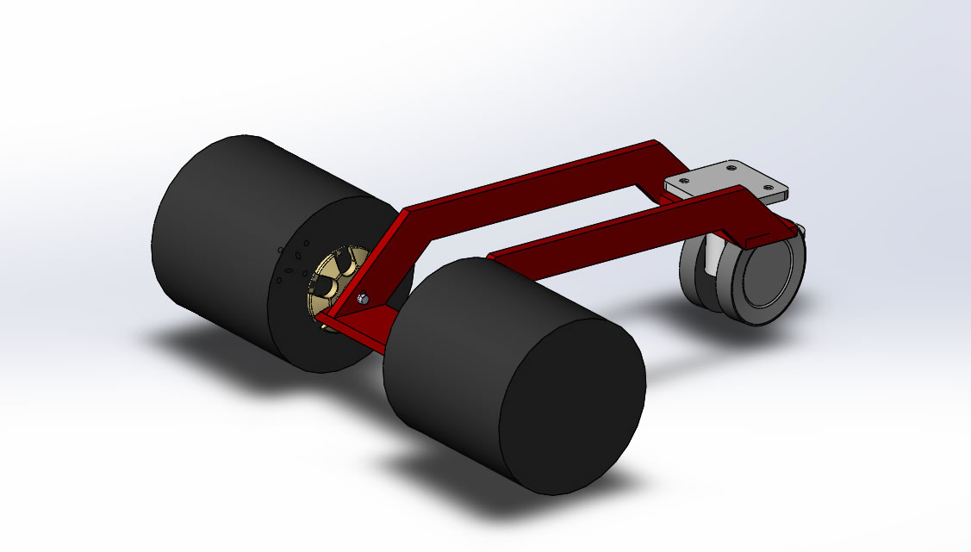

The current shape is actually a conclusion, after running some tests using equal wheels on a computer simulation, on various conditions and angles.

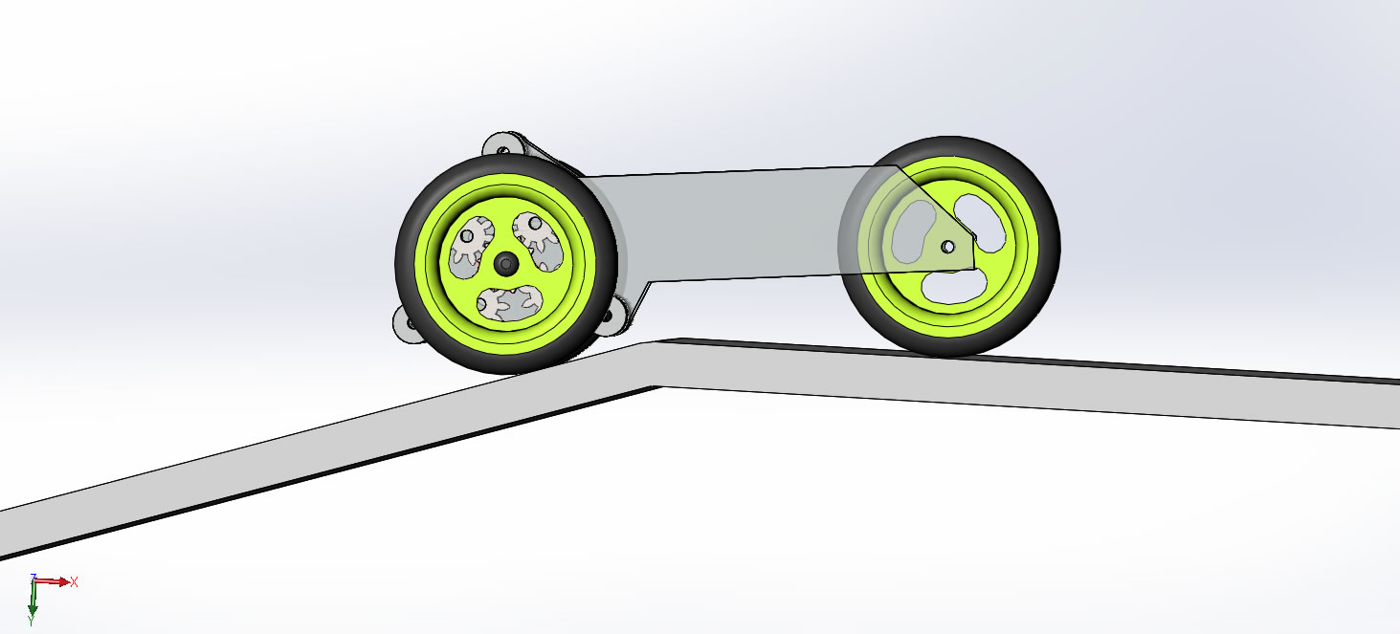

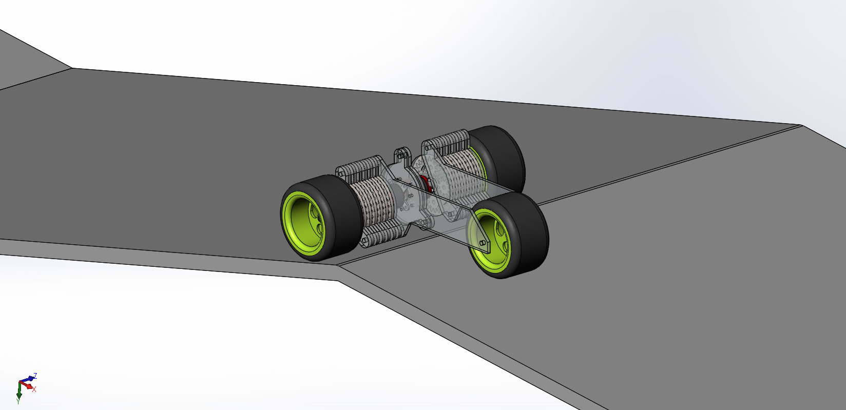

The wheels in front are self-propelling, using two brushless engines (BL Outrunner D28x26/ 1290KV), one engine each.

First tested on the simulator:

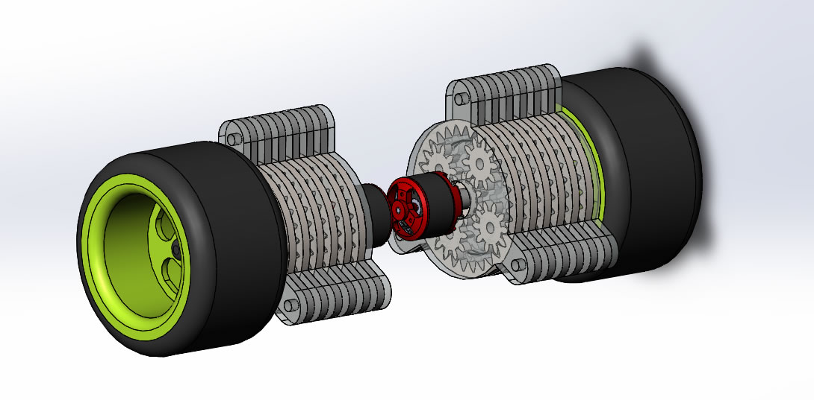

and then tested live, after the components have arrived:

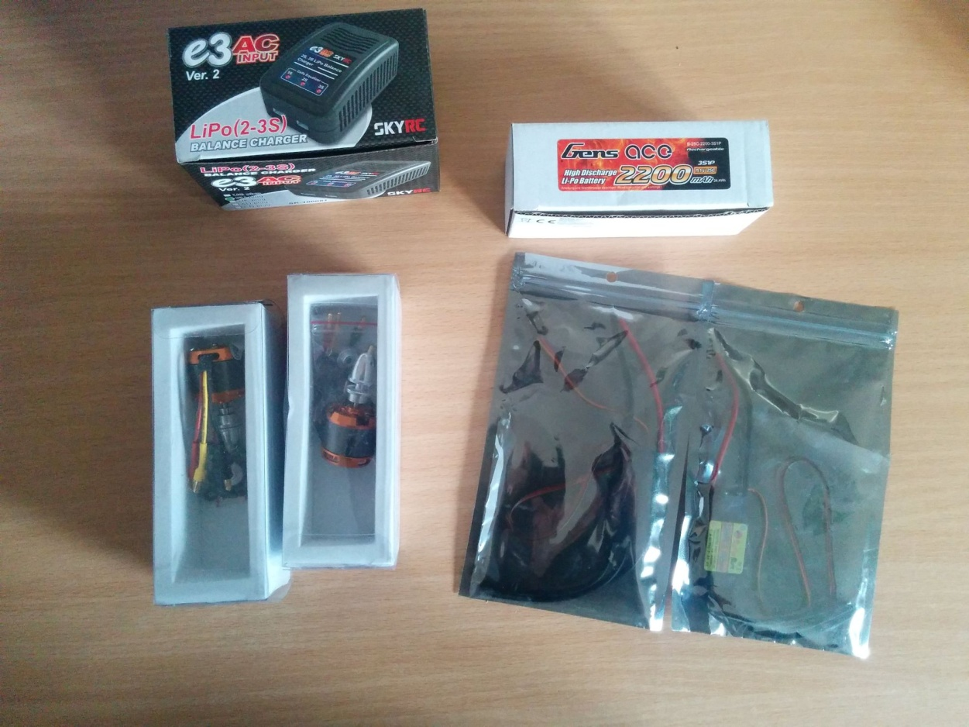

Many of the components have been printed on own 3D printer (better than composite wood or plastic), specifically for this concept, to support the model:

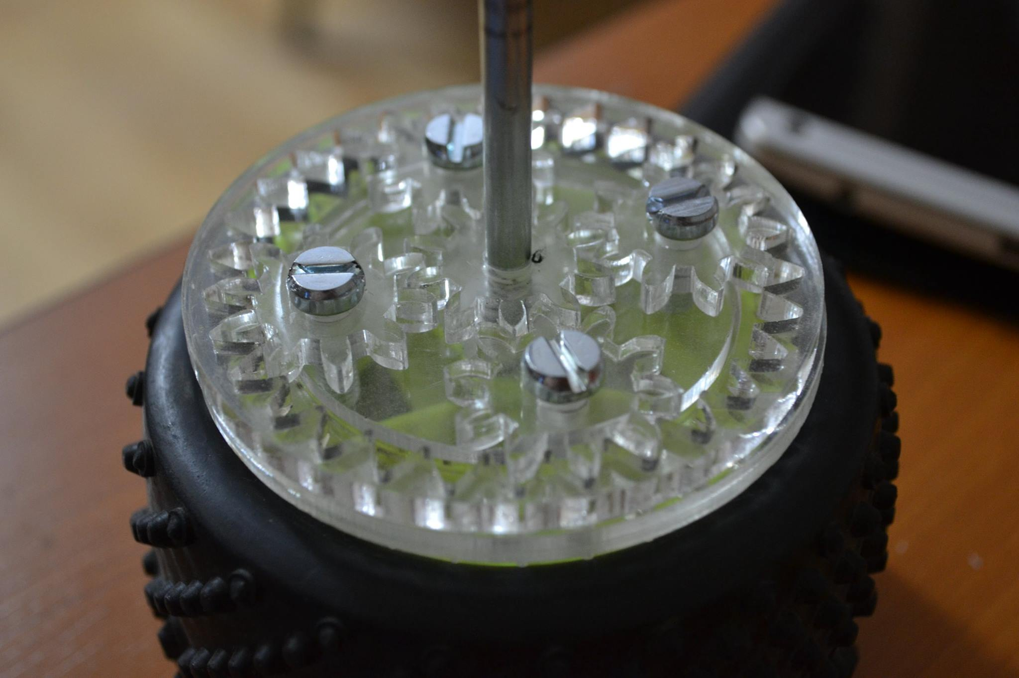

The car makes turns by slowing down either wheel progressively - just like a tank.

The wheel in the back is fixed and its only purpose is to sustain the car's brains - that is an Arduino board which receives signals through a BlueTooth card, interprets it and forwards it to the car so it can either START, STOP or make turns LEFT and RIGHT.

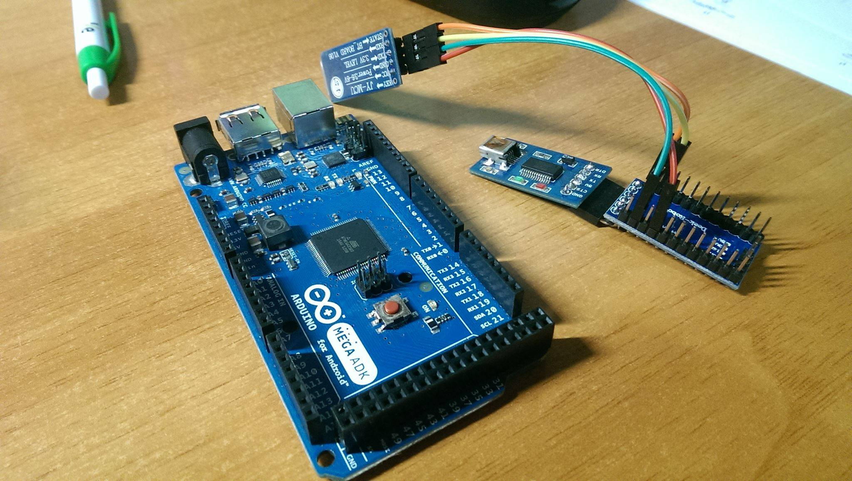

Bibliography:

http://www.electromobility.ace.tuiasi.ro/files/Technical_requirements.pdf

Community Sharing on Social Media:

https://www.facebook.com/A3-890601257722690/